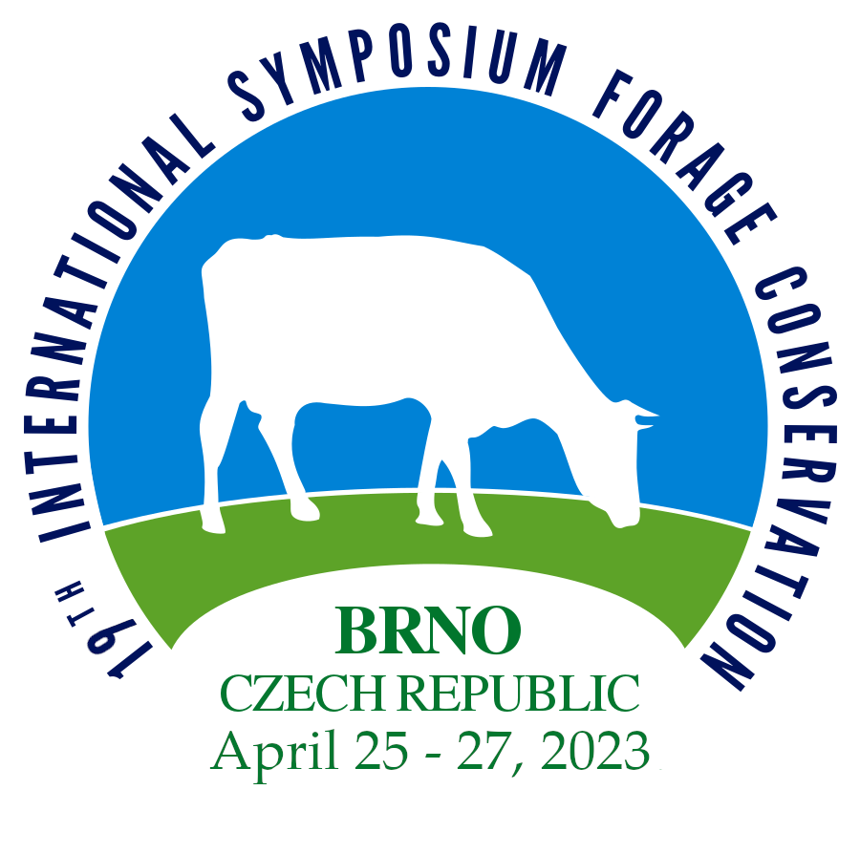

Types of partnership

Dear all, we would like invite you to participate in International symposium, organized for the 19th time .

19. International Symposium: Forage Conservation

Will be held 25th - 27th April 2023

Addresa of symposium:
NutriVet, s.r.o. Václav Jambor
Vídeňská 1023 e-mail: isfc@seznam.cz
69123 Pohořelice mobil.: + 420 606 764 260
Tel.: + 420 519 424 247

Company introduction opportunities at the symposium
We offer you the possibility to participate in the presentation of the symposium as an exhibitor, or partner. We will be happy to discuss with you all the possibilities and conditions of our cooperation.

Please fill out the form available below.

Once the form is delivered to us, we will contact you and arrange further action.

If you want to discuss your requirements or customize the partner package to your company´s needs, please contact us.

This time we celebrate 200th anniversary of born of J.G.Mendel
Place of meeting will be at Opatství staré Brno řádu sv. Augustina
BRNO, Mendl Square www.opatstvibrno.cz

Offer of symposium partners presentation

Diamant partner …………………….…………50.000 CZK excluding VAT
Exhibition area in the foyer (table + chairs + 1 x company banner).
3 x free participant registration throughout the event.
Company logo on the banner placed in the main hall.
Company logo placed in proceedings and on the symposium website.
Promotional bags.

Gold partner ………………………………………40.000 CZK excluding VAT
Exhibition area in the foyeranteroom (table + chairs + 1 x company banner).
2 x free participant registration throughout the event.
Company logo on the banner placed in the main hall.
Company logo placed in proceedings and on the symposium website.
Promotional bags.

Silver Partner ……………………………………….30.000 CZK excluding VAT
Exhibition area in the foyer (table with chairs + 1x company banner).
2x free participant registration throughout the event.
Company logo on the banner placed in the main hall.
Promotional bags.

Bronze partner ……………………………………..20.000 CZK excluding VAT
Exhibition area in the foyer (table + chairs + 1x company logo).
1x free participant registration throughout the event.

Promotional items ……………………………………5.000 CZK excludingt VAT
Promotal items after agreement – a customized pencil and notepad

INFORMATION
Order
Please send a completed order by September 30th, 2022, to e-mail address isfc@seznam.cz
We will confirm the order delivery and arrange a meeting to specify the cooperation.
Promotion items
Please, send us parameters of your promotion items (like weight, sizes, etc.) before September 30th 2022 to address NutriVet Ltd., Vídeňská 1023, Pohořelice 69123.
Company logo
Please, can you send a company logo in vector image file (ai, cdr, eps) together with filled, signed and stamped binding order.
Company logo placed in the conference hall
Company logo in the form of a banner.
Payment
Payment or ordered services will be considered on the basis of an advance invoice with a due date. After receiving the payment, we will send you a tax receipt
Symposium website www.isfc.eu
Registration form
Name of company:
Billing address: Street:
Town: ZIP Code:
Tax ID: ID:

Correspondence address: Do not report i fit is the same as the billing address
Diamant Partner 50.000 CZK excluding VAT
Golden partner 40.000 CZK excluding VAT
Silver partner 30.000 CZK excluding VAT
Bronz partner 20.000 CZK excluding VAT
Input to the bag 5.000 CZK excluding VAT

Sympozium Are you intersted in using the symposium? If YES please the following (the lecturer must be registrated separately as a participant in the symposium(:

Name of lecturer:
Operation of the stand:
Please fill in teh names of two people in chargé of market stall during the symposiu. The installation instruction for the stand will be sent after the invoice payment. Other empyess of yuor compyny who wish to participate in the symposium must register at www.isfc.eu

In ……………………………………. On…………………………………..
Name and surname of a responsible person:

1.…………………………………………………………….
2…………………………………………………………….
3……………………………………………………………..

Signature……………………………………………. Stamp……………………………………

