Czech Technology Platform for Agriculture
in cooperation
with the Institute of Animal Science (IAS)
invites you to a workshop
Precision farming - Nutrition
which takes place on August 12, 2019 from 10:00 to 14:00
in the meeting room and on the farm IAS Prague Uhříněves

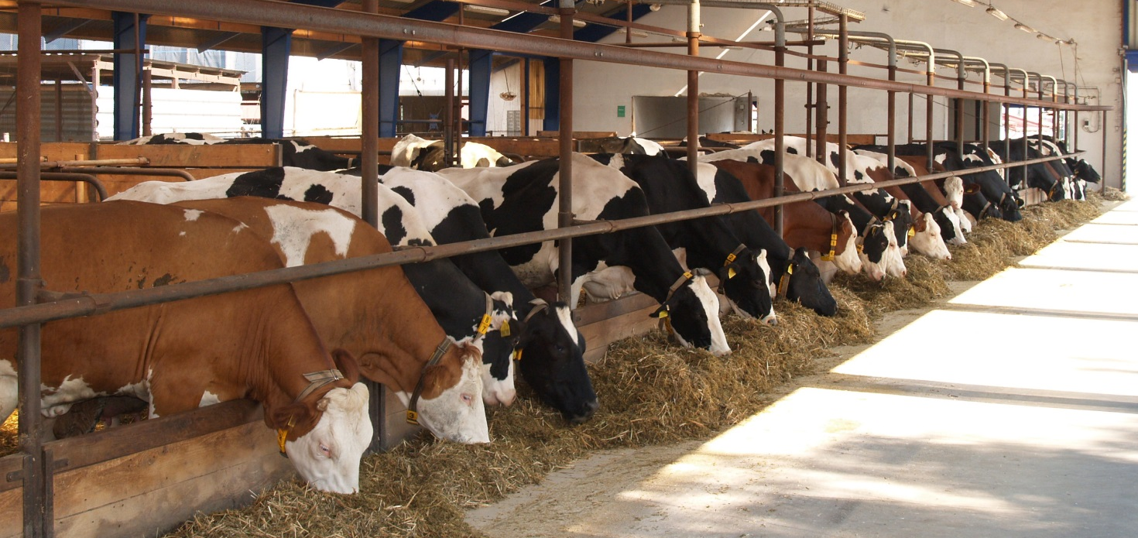
Workshop is supported by Ministry of Agriculture
and The Czech Technology Platform for Agriculture

Information for participants:
- Presentation 9:30, opening at 10:00, ending at about 14:00

- Theme 1: Precision farming in the Czech Republic
The calibration in NIR spectroscopy of dry matter (DM); the measurement of DM and other nutritional value indicators in fresh forage and silage using NIRs; the measurement of pH in rumen and other related indicators to reduce the risk of acidosis.
Dr. Radko Loučka introduces the issue and moderates the discussion.

- Theme 2: Precision farming in the People's Republic of China
To develop cost-efficient technologies which enable utilization and preservation of new protein forage for animal feeding; efficient utilization of new protein forage based on the precision livestock farming (PLF) technology.

prof. Chuncheng Xu introduces the issue and moderates the discussion.

- Inspection of laboratories, experimental stables and storage facilities on silage (Netluky farm).
- Refreshments and lunch during the seminar provided free of charge.
- Fee: free. Papers will be published.
- After lunch, a train transfer to Brno will be organized, where ISFC will be held.

Please submit your articles (up to 2 pages) by 30th March 2019, applications until 30th May 2019. Send by e-mail to loucka.radko@vuzv.cz; Questions to call +420 731 650 836.
In case of interest we can book the cheap accommodation at VÚŽV pension in Uhříněves during the weekend, recommend hotel in Prague, or book a train ticket to Brno.
Registration of participant of workshop 12.3.2019 Prague

Name and Surname: ....................................................................................................

Address of organisation................................................................................................

Tel: / e-mail:..................................................................................................................

Tittle of speach in English:

….....................................................................................................

Tittle of speach in Czech (or Chinnesse) languege:

……………………………………………………………..………………………………………..

Authors (name, affiliation):

.......................................................................................................

Please, registration send to 30.3.2019 and your article to 30.5.2019 on address loucka.radko@vuzv.cz
Your article have to be written in Times New Roman 10 b. format, not more than 2 pages, It is not necessary to have a scientific character.

